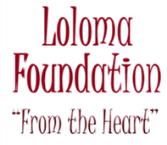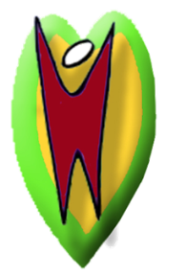

Loloma Foundation 2013 Work

What a great year we had! With the help of 86 volunteers, the following is a recap of what was accomplished.
Lance Hendricks and Linda Kwasny flew to Suva, Fiji in January to unload our 40ft shipping container of various donated supplies and another 40ft container of medical supplies donated by Direct Relief International and Americares.
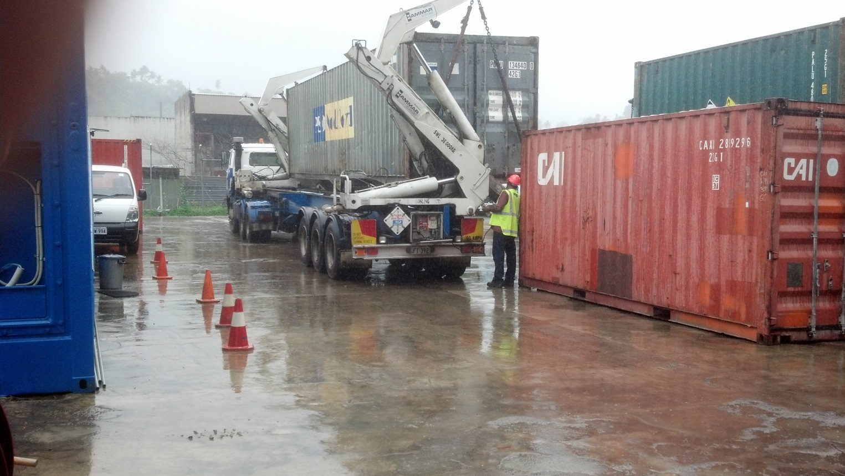
Fifty cases of clothing were given to three village leaders for a rummage sale which supports scholarship programs, solar lighting programs and village sustainability projects. Other materials were given to Colonial War Memorial Hospital, the central hospital in Suva, and the Samabula Old Folks Home in Suva and textbooks forpredetermined schools in the greatest need. Part of the remaining materials were organized for the Navutu Stars team and shipped out to the western Yasawa Islands. The larger part of materials were shipped out to Taveuni Island for the April teams. Lance and Linda then went out to Taveuni Island the second week to sort and place all those supplies in the storage room at Taveuni Hospital. The room had been refurbished with storage shelves and secure windows and doors thank to the great work by Dennis Irwin, owner of Aroha Taveuni Resort.
January Navutu Stars mission, Western Yasawa Islands of Fiji
Our fabulous dental teamtreated a total of 422 patients in 6 separate operatories, including the deck of the spa at Navutu Stars resort which became the hygiene area. Navutu Stars closes the resort to allow the Loloma Foundation team the complete facility to work in. The resort provides free rooms for the team foodbeing the only cost there.
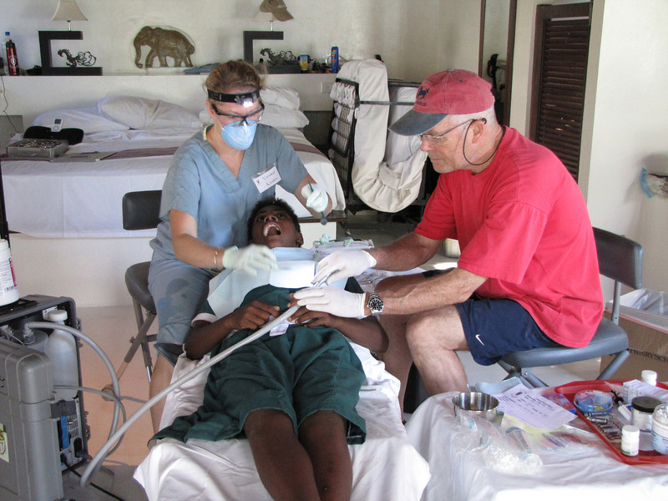
In all, they completed the following:
Extractions: 258
Fillings: 131
Varnishes: 178
Sealants: 261
Cleanings: 72 for a total of 900 procedures on the 422 patients!
Our energetic, mobile general medical team saw a total of 761 patients in a total of 8 different islands/villages! Each day they packed their mobile pharmacy boxes and left
2
aboard the Dr. Phil Forever boat and arrived back late each afternoon, drenched, tired but happy. Some of the commutes were challenging!
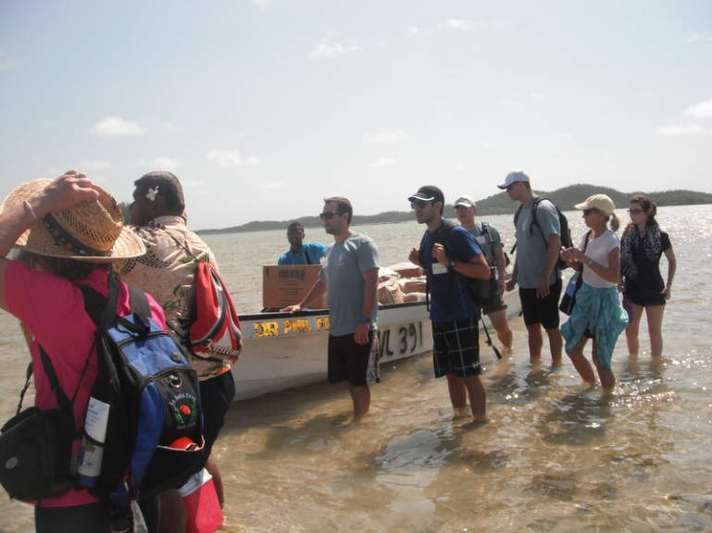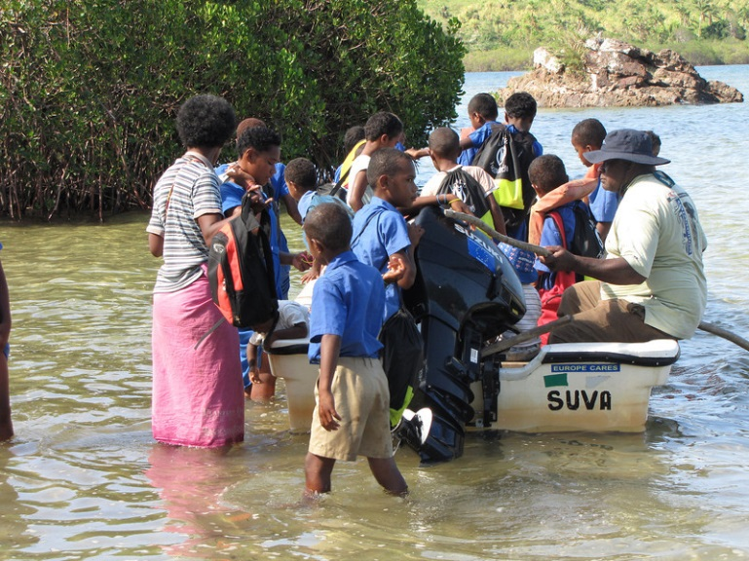
The medical team arriving on island. The patients from surrounding islands.
The team of 20 varied in ages from 15 to 68, hailed from various parts of the US, Canada and Fiji and were exceptionally cohesive.
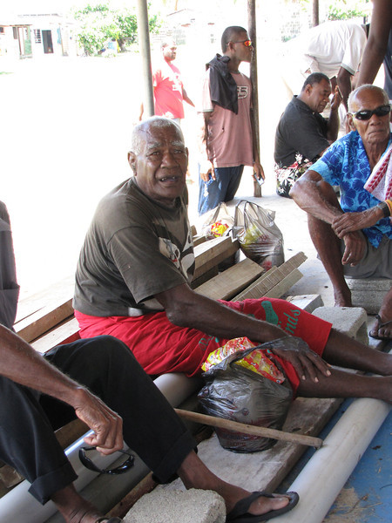
A typical clinic scene.
3
Thank you to the following for your dedication and willingness to thoughtfully get through the numbers of patients each day:Dave and Heather Nicholls, Lynne Scannell, Liam and Kelly Chambers, Evelyn Chung, Kirsten McCarville, Bob Duell, Joe Hahn, Lynne Calkins, Jacinda Neilson, Michelle Sutanto, Dan Given, James Hart, Neil Kalra, Natalie Thigpen, Teresa Moore, Linda and Rich Kwasny and Joseph Dulunaqio.
March Solomon Islands mission
This is the trip which we bill as the “make it up as you go along” mission because of it’s remote unpredictability. Actually, it was well-orchestrated on the Solomon side, thanks to Dr. Rodney Talo and everything went incredibly well! Beautiful weather, smooth sailing and a dedicated, hard-working group added to its success. We chartered the Bilikiki, a 125 ft dive boat, as our transportation and accommodations. It was a 15 hour transit overnight from Honiara, Guadalcanal to Kirakira Hospital on Makira Island.
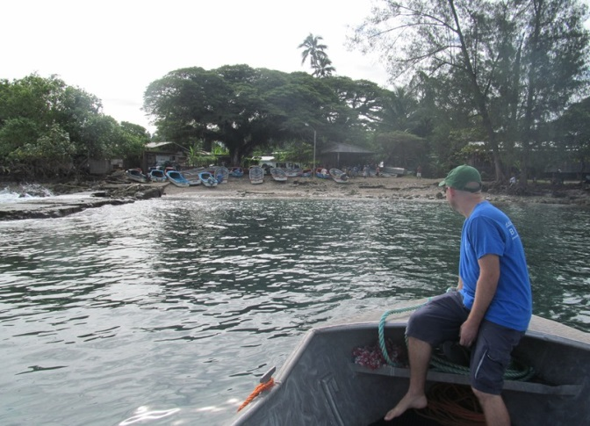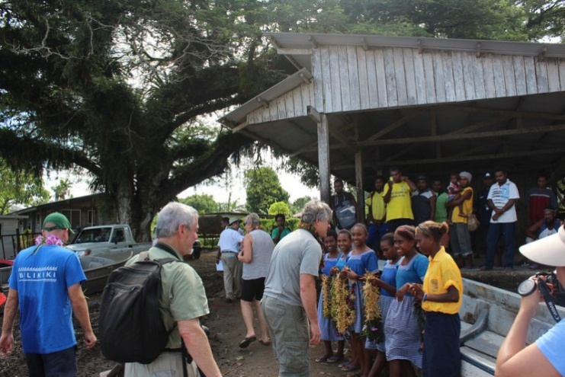
The daily Solomons village landing. The Solomons greeting party.
Our experience at the Kirakira Hospital on the remote island of Makira was very productive. In the O.R., our plasticsurgeon and general surgeon kept two tables running with major and minor surgery each day. There were some life-changing plastic surgeries and plenty of hernias among the 40 surgeries performed. Our two O.R. nurseswho had each been to the Solomons several times kept everything organized and flowing smoothly.

4
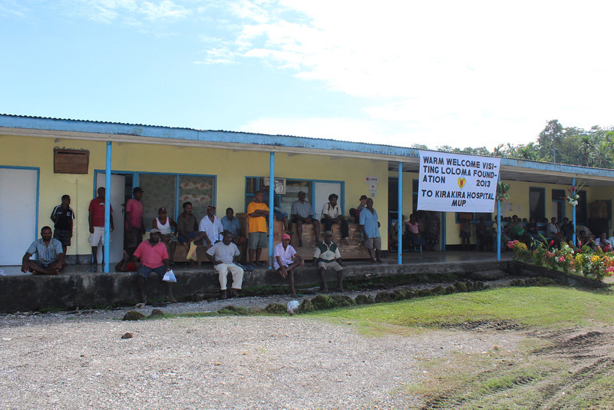
The patients awaiting our arrival. MUP stands for Makira-UIawa Province

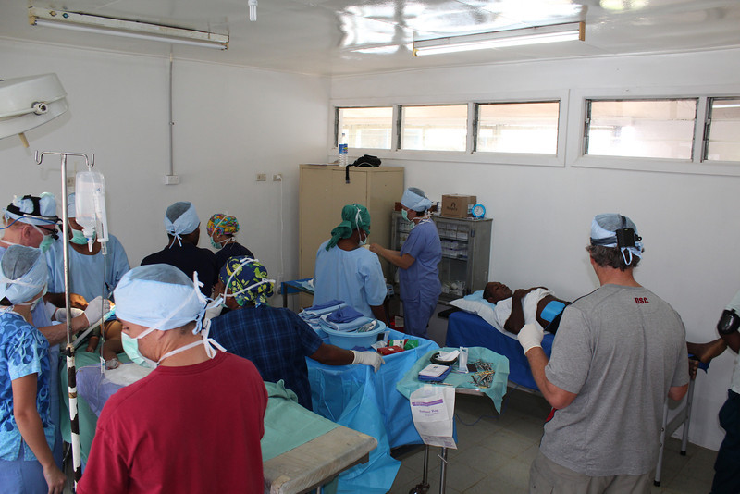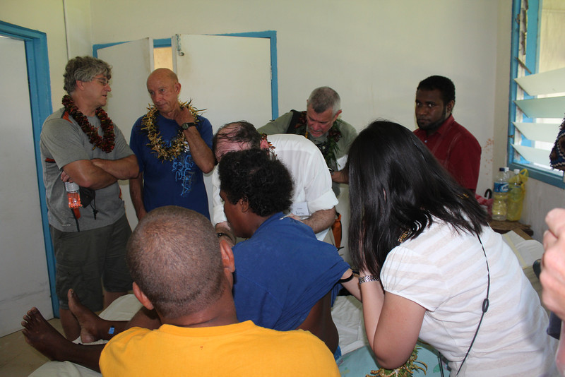
Two surgeries at a time. Hospital Rounds

5
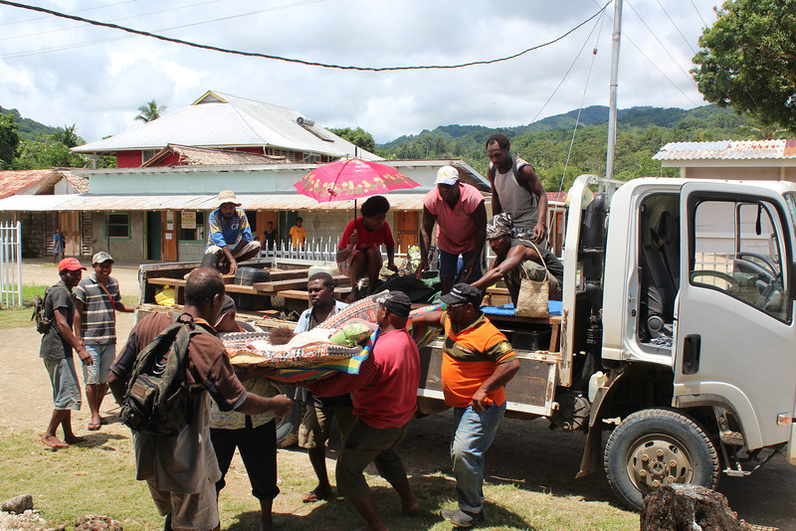
Solomon Islands Patient Transport
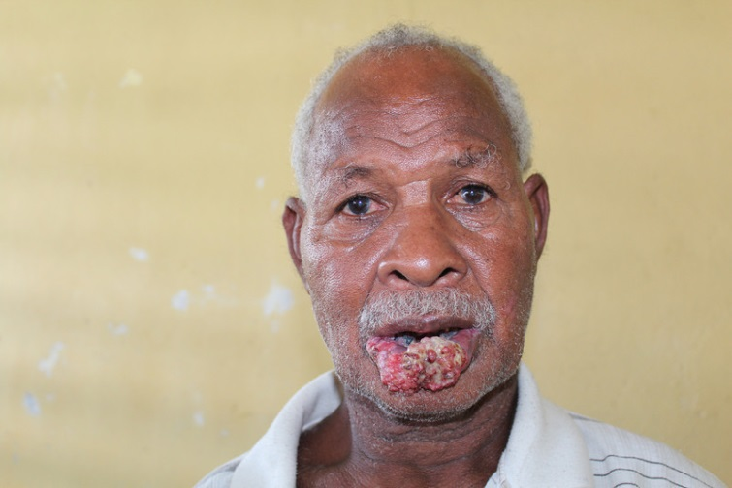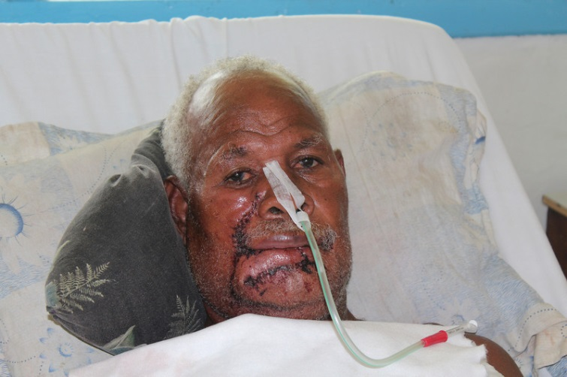
Before and after lip cancer excision and reconstruction.

6

Out in the field, our general medical team traveled each day (in the hospital ambulance) to rural nursing aid stations to conduct clinics seeing over 500 patients. Makira is incredibly remote and untouched and it was a privilege to work with the hospital staff. The hospital was built in the 1960’s with very limited facilities. Jimmy Inikalo, a nurse anesthetist, Clay Siosi-Lewi, a surgery resident andNerrie Raddie, ascrub nurse, all from the main hospital in Honiara, were flown over to work with our team. What a great addition!
We were more than well-cared for on the Bilikiki and grateful for the effort everyone made in-country to accommodate our mission.
Our thanks to the fabulous team:
Mark Saroyan, Jerry Murphy, Lance Hendricks, Gerry Schneider, Teresa Moore, Lily Hsu, Bill Jurewitz, Stacy Strah, Jared, Josh, Vida Spotkov and Kapua Meyer, Chis Hawkins and Linda Kwasny.

April Taveuni mission
We returned from the Solomons and went directly to our home base of Taveuni Island to set up for a month of four separate medical, dental and surgical missions. We were happy to settle into our home at Aroha Taveuni, where owners Dennis and Ngaire take great care of us.
Week One:
Our intrepid general medical team had the responsibility of traveling each day to a remote location to run clinics and screen for the ensuing weeks of cataract and general surgeries.

7
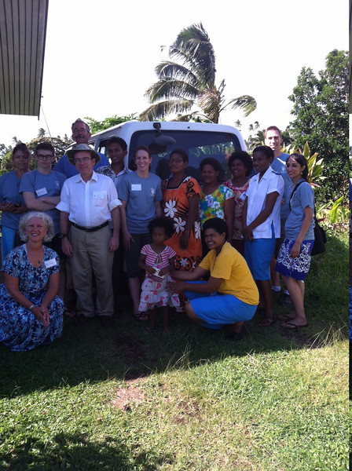
Taveuni Medical Team

The team was BUSY!! In six days they managed to collectively and very thoroughly screen 1322 patients in six different locations. By the end of the week we had more than filled all the dental and surgical time slots and dispensed a ton of medication. The weather was great. Drinks, an evening swim, stories and dinner by the pool were always a welcome respite from the work.

8
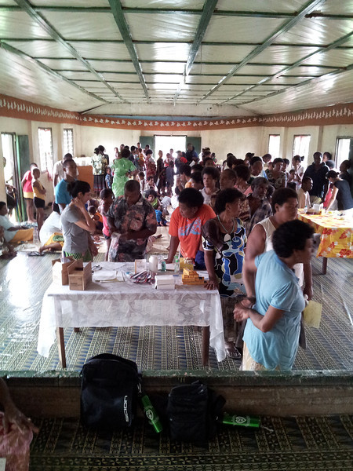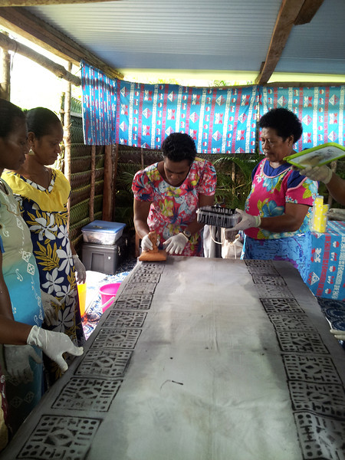
A typical Taveuni clinic. The sustainability project.
Additionally, the Duavata women’s sustainability project began it’s month-long training program with Beatrice Firm directing 12 women on the manufacturing of sulus, woven bags and jewelry. After five weeks with the women, we have three stunning, practical products which will debut at the fundraiser on OCTOBER 19TH.

Our thanks to the fun, cohesive and well-oiled machine of a team:
Sarah and Mark Jerome, Amee Amin, Ana Crissien, Jerry Murphy, Janet and Jay McDonald, Bill Jurewitz, Aaron Smith and Lance Hendricks.
Week Two:
The optometric and cataract team arrived and began setting their OR and clinics on the day of arrival. In all, 1005 were screened, tested and given readers, sunglasses or pre-refracted glasses. Most all on this team are long-time Loloma volunteers. It’s an honor to welcome them each year. We also appreciate having Bernadette Ganilau, our
9
Loloma-Fiji board member who comes to help each year and Taveuni resident Ronna Goldstein. Suva resident Lily Chung also joined the team.
Meanwhile, the ophthalmology team performed 32 eye surgeries including cataract and surgicalpterygia removals. This is the infamous team who passes out really good chocolate to all the recovering patients!
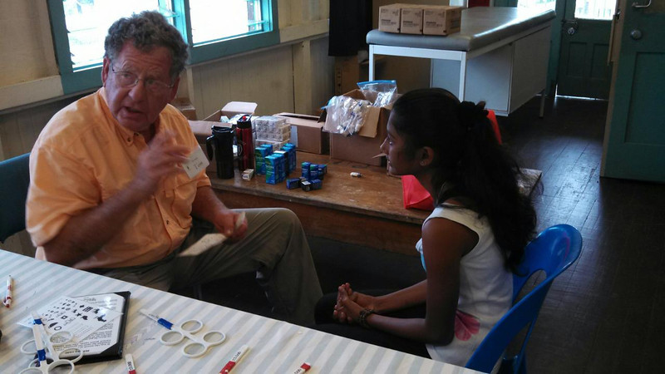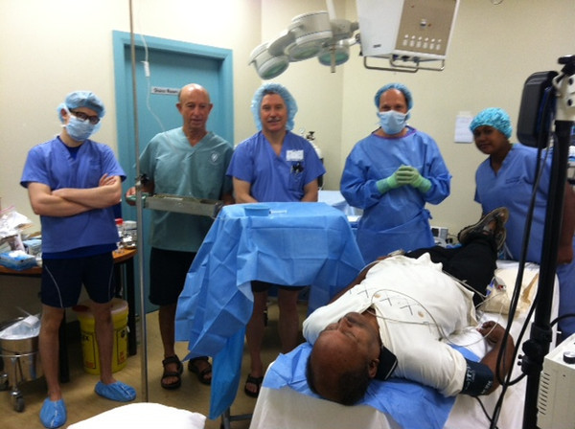
Dr. Tom Rippner, OD at work. The team preparing forcataract surgery.
Thank you, eye team for doing your part to restore vision:
Sharon and Tom Rippner, Mike Limberg, Rhonda Hunter, John Garber, Trang Ta, Sally Nettleton, Bruce Smith, Aaron Smith, Lia Guy, Lance Hendricks and Linda Kwasny.

Week Three:
Incoming teams included the Maxillo-facial surgical team and the Dental teams. This week, there were some incredible, life-changing specialty surgeries performed in the O.R. In between the big major surgeries, there were minor surgeries done. Surgeries moved along seamlessly, thanks to the three skilled nurses who assisted alongside the physicians and in recovery. There were 19 surgeries performed by the Maxillo- were life changing such as the cleft lip repair on an 8 week old child.

10
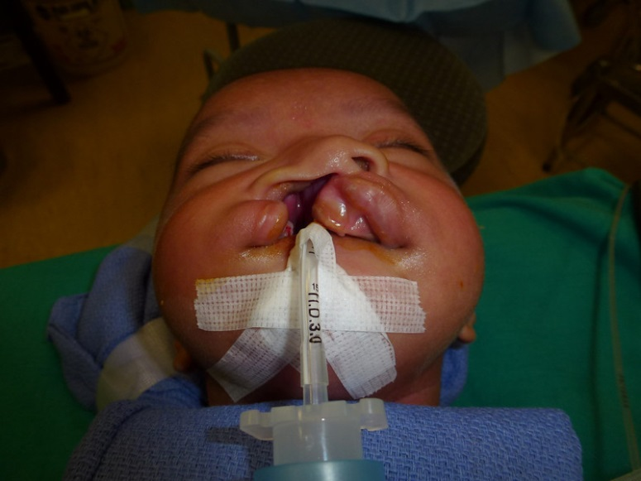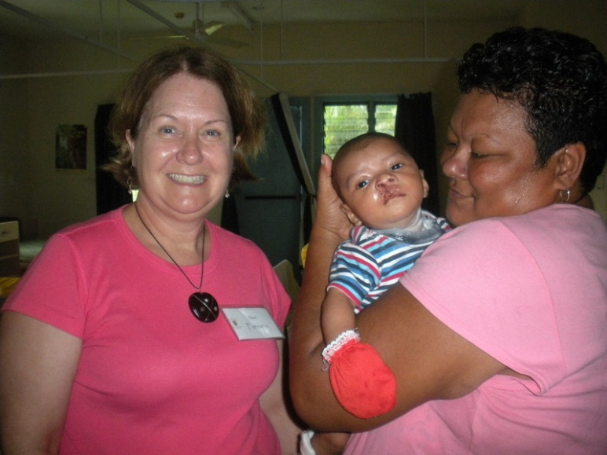
Ready for surgery. One day post op with Nurse Patricia and grandma.
The dental team was incredibly busy each day, working with resident dentist Alvin Sidal. Each day, there were three chairs doing extractions and remarkable restorative work (front teeth). Additionally, two hygienists worked tirelessly all day cleaning, sealing and varnishing teeth.
For the first week, totals were:
Exam only: 17
Extractions: 214
Fillings and restorations: 107
Cleanings, sealants and varnishes: 73

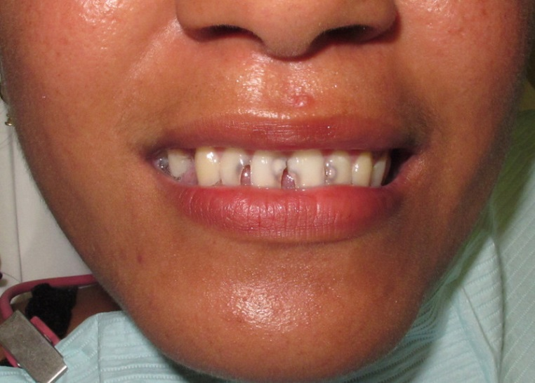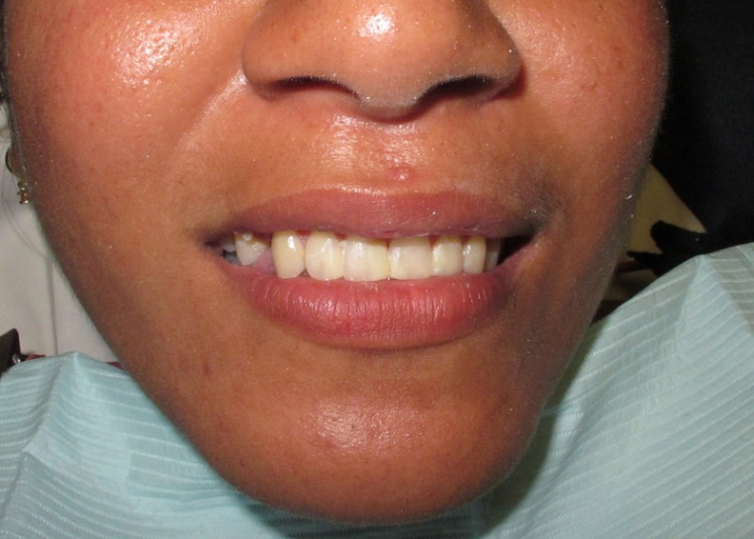
11
Thank you, team three, for sharing your skill sets and for your tireless presence:
Andy Softley, Elizabeth Van Nieuwenhuyzen, Krista McGuire, Pat Tillson, Caroline Bennett, Sandy Ratner, Craig Bloom, Sarah Brown, Julie Richards , Jennie Hall, Jeff Dow, and Lance Hendricks.
Week Four:
Last, but not least, our small but powerful general surgery team arrived to tend to the overbooked list of surgical procedures, both major and minor. A hospital ward was shifted and cleared in preparation for the people who would need to spend a night or longer in the hospital. Without trepidation or hesitation, surgeries began and they worked 11 hour days to get through the list and not disappoint those who had traveled from other islands for surgery.

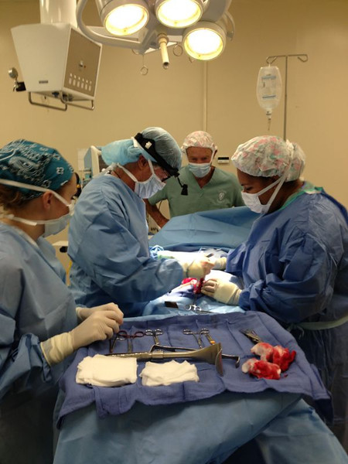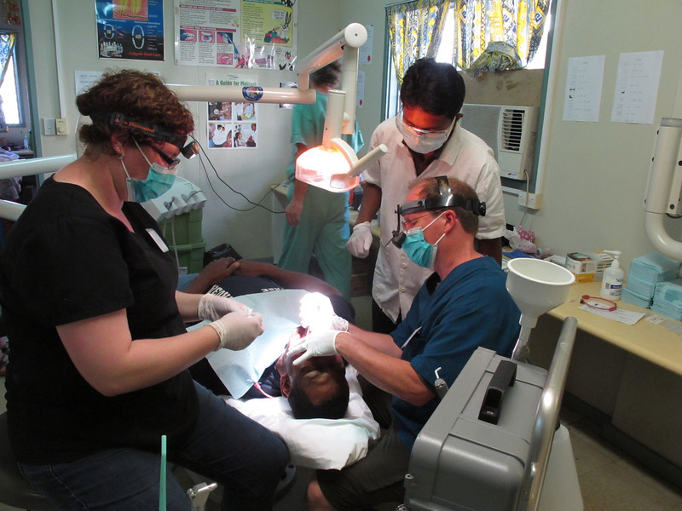
Dr. Kula on the right above, the medical officer at Taveuni Hospital assisted at many of the surgeries.There were a total of 48 major and minor surgeries performed for the week. Most importantly, EVERYONE was treated except one person who will return next year.

12
Not surprisingly, our dental team was incredibly busy again with resident dentist Alvin working with our dentist and assistant. Koini, the resident hygienist worked the entire week cleaning and sealing teeth as well. Our fabulous volunteers never faltered, even on the day they walked in to find the office deluged in 2 inches of water from a leaking pipe. After they mopped up all the water, the show went on!
This week, the totals were:
Exam only: 39
Cleanings, sealants: 42
Extractions: 86
Fillings: 133
Team Four exhibited tireless energy and willingness to do whatever was impressive. TheOR team’s humor was a never-ending source of entertainment and brought lightness to those long days:
Judy and Jack Sherman, Beatrice Firm, Sarah Williamson, Jeff Johnsrud, Lance Hendricks and JJ Komadina.
The staff of Taveuni Hospital were an absolute delight to work with and were integral members of the teams. We’re sure we overworked all of them but they always had smiles and were as thrilled as the patients to have this care provided.
Needless to say, it was an incredibly productive year. We owe this success to you our generous donors and our volunteers, who usetheir precious vacation days and pay to come halfway across the world to extend a hand to the underserved and gracious people of the south pacific.
Without our wonderful volunteers and all our generous supporters this never could have happpened.
P. Lance Hendricks. MD
President, Loloma Foundation
549 Albion Street
San Diego, Ca. 92106
lhendricks@lolomafoundation.org

13
Board of Directors:
Robert Duell, DDS, Janet DuBois, MD, P. Lance Hendricks, MD,
Jennifer Komadina,RN, Linda Kwasny, Lynne Scannell, MD & Bob Sykes

P.O. Box 2764
Del Mar, CA 92014
www.lolomafoundation.org

501 (C) 3 Tax ID
04-3702334

